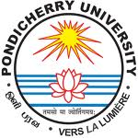
PONDICHERRY UNIVERSITY

(A Central University)
DEPARTMENT OF OCEAN STUDIES AND MARINE BIOLOGY
Brookshabad Campus, Port Blair, Andamans – 744 101

Vacancy Status for M. Sc., Marine Biology, Port Blair Campus as on 29.06.2017

Category | Number of seats | Filled | Vacant
General | 24 | 11 | 13
OBC | 14 | 07 | 07
SC | 8 | 01 | 07
ST | 4 | 04 | NIL
PH | 2 | 0 | 2
Total | 52 | 23 | 29

There are only two (2) number of vacancies available in the Ladies Hostel.

Jayant Kumar Mishra

